5.15: a)
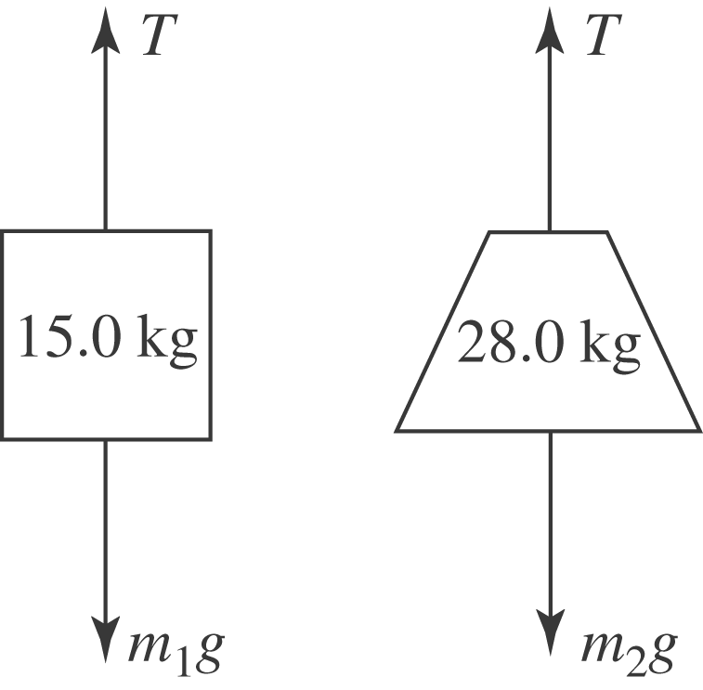
The tension is related to the masses and accelerations by
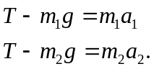
b) For the bricks accelerating upward, let 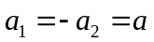 (the counterweight will accelerate down). Then, subtracting the two equations to eliminate the tension gives
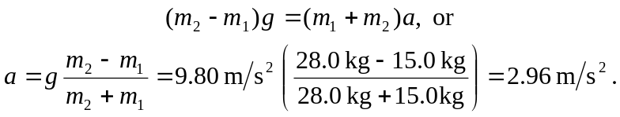
c) The result of part (b) may be substituted into either of the above expressions to find the tension 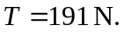 As an alternative, the expressions may be manipulated to eliminate a algebraically by multiplying the first by 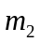and the second by 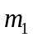and adding (with 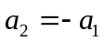) to give
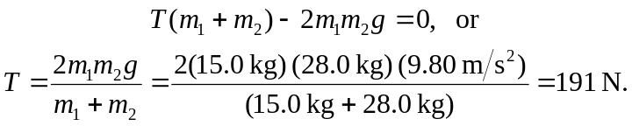
In terms of the weights, the tension is
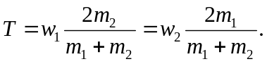
If, as in this case, 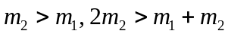and 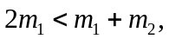 so the tension is greater than 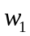and less than 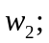this must be the case, since the load of bricks rises and the counterweight drops.

